PAPER TITLE *(14pt Times New Roman, Bold, Centered)*

Name Surname1, Name Surname1*(12pt Times New Roman, Centered)*

*1Department of Applied Geology and Geoinformatics, Faculty of Geology and Mining, Polytechnic University of Tirana, Albania* *(10pt Times New Roman, Centered, Italic)*

*\* Corresponding author: email:*

# ABSTRACT

*(12pt Times New Roman, Bold, Centered)*

This file provides a template for writing papers for the GENRE 2025 Conference. The full paper in MS Word file shall be written in compliance with these instructions. It will be converted into Portable Document Format (PDF), before publishing. An abstract not exceeding 300 words should appear on the top of the first page, after the title of the paper. *(11pt Times New Roman, Justify)*

***Keywords:*** *This section should be written in italic and include a maximum of 6 keywords related with the study. (10pt Times New Roman, Italic)*

# INTRODUCTION

The main text of the manuscript should be divided into sections. The paper length, including figures, tables and references should **not exceed 8 pages**. Papers are to be prepared in English and SI-units shall be used. Acronyms should be written out at their first appearance.

## Paper Format

The authors **should use this template file** to write their manuscripts. Please note the following details: this template is on A4 (210 x 297 mm) page format with 25 mm margins on left, right, top and bottom. Header and footer shall be positioned 15 mm from the edge. All text paragraphs should be single spaced, with first line intended by 10 mm. Position and style of headings and subheadings should follow this example. No spaces should be placed between paragraphs. Please **DO NOT** change any of the above mentioned page, paragraph and font settings.

## Headings

It is recommended to use a maximum of three levels of headings as shown in Table 1. Use dots to separate the numbers of the levels, as shown: **1; 1.1; and 1.1.1** (as used in this document). It is recommended to use the following paper structure: Introduction, Methodology, Results, Discussion, Conclusion, and Recommendations.

### Fonts

Papers should use 12-point Times New Roman font. The styles available are bold, italic and underlined. It is recommended that text in figures is not smaller than 10pt font size.

### Tables and Figures

Figure and table captions should be sufficient to explain the figure or table without needing to refer to the text. Figures and tables not cited in the text **should not be presented**. Figures should be identified with both a number and a caption, as shown in the example below. The number and title must be placed below the figure. In Microsoft Word, use the command [Insert | Caption] to add the figure number and caption. The font should be Times New Roman, 10 pt, with 6 pt space before and 6 pt space after the paragraph. The following is the example for Table 1.

Table 1 Summary of formatting rules

|  | **Font** | **Alignment** | **Space above** | **Space below** |
| --- | --- | --- | --- | --- |
| Title | 14pt Times New Roman Bold | centred | 12pt | 12pt |
| Main text | 12pt Times New Roman | justified | 0pt | 6pt |
| Heading 1 | 12pt Times New Roman Bold | left | 10pt | 6pt |
| Heading 2 | 12pt Times New Roman Bold | left | 6pt | 6pt |
| Heading 3 | 12pt Times New Roman | left | 6pt | 6pt |

Tables and figures should be placed as close as possible to their first mention in the text. They must be numbered consecutively using Arabic numerals. Table titles should be centered and positioned above the corresponding tables, while figure captions should be centered and placed below the respective figures. An example is provided in Figure 1.

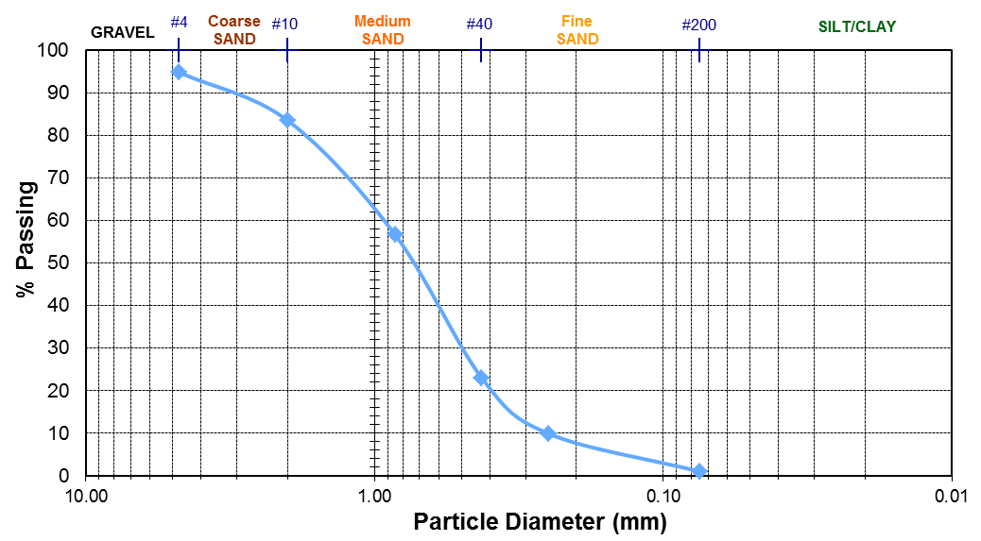

Figure 1 Title of Example Figure

### Equations

Each equation should be presented on a separate line from the text with a blank space above and below. Equations should be clear and expressions used should be explained in the text. The equations should be numbered consecutively at the outer right margin, as shown in Eq. (1) and (2) below:

|  |  |
| --- | --- |
|  | 1 |
|  | 2 |

In Microsoft Word, use the command [Insert | Caption] to add the equation number and caption. The font should be Times New Roman, 10 pt, with 6 pt space before and 6 pt space after the paragraph. Table and Caption Figure Styles are available in this template for tables and figures.

# Methodology

The Methodology section describes in detail how the research was conducted, allowing readers to assess the validity and reliability of your study. It explains your research design, data collection processes, materials or instruments used, and the procedures followed. This transparency helps others replicate the study if needed and shows that your methods are appropriate and rigorous for answering your research question. Explain how the research was conducted.

# Results

The Discussion interprets the significance of your findings in the context of the research question and existing literature. It explains what the results mean, explores implications, and discusses how they relate to previous studies. This section also addresses limitations, considers alternative explanations, and suggests areas for further research, providing a critical evaluation of your study. Present the findings without interpretation.

# Discussion

The Discussion interprets the significance of your findings in the context of the research question and existing literature. This section also addresses limitations, considers alternative explanations, and suggests areas for further research, providing a critical evaluation of your study. Interpret and explain the results.

# conclusion

The conclusion should briefly restate the purpose of the paper, summarize the main findings, and highlight their importance. It may also mention any limitations and suggest directions for future research, tying everything together clearly and concisely.

# REFERENCES

All references cited within the manuscript should be formatted according to the latest edition of the APA Style, (Price, 2009). The references should be listed based on names as shown below.

Price, D. G. (2009). *Engineering Geology, Principles and Practice* (1st ed.). (M. H. Freitas, Ed.) United Kingdom: Springer.

# SUBMITTING THE Paper

The manuscript can be submitted electronically on or before **September 10, 2025**, by e-mail to the e-mail address: [info.genre@fgjm.edu.al](mailto:info.genre@fgjm.edu.al).